**Kubernetes - 01**

1) Setup Minikube in your local machine.  
  
Install minikube on windows:

===========================

1) Install Docker on windows.

https://docs.docker.com/desktop/install/windows-install/

2) Install Oracle box on windows

https://adamtheautomator.com/install-virtualbox-on-windows-10/

3) Check system info in CMD

systeminfo

4) Install Minikube using power-shell

https://minikube.sigs.k8s.io/docs/start/

5) Set the minikube path to environmental variable

6) Restart power-shell and start minikube

minikube start

To check minikube IP use : minikube IP

To ssh to minikube: minikube ssh

To connect or check the pods : kubectl get pods

To see minikube on dashboard: minikube dashboard

**Step -1**  
  
  
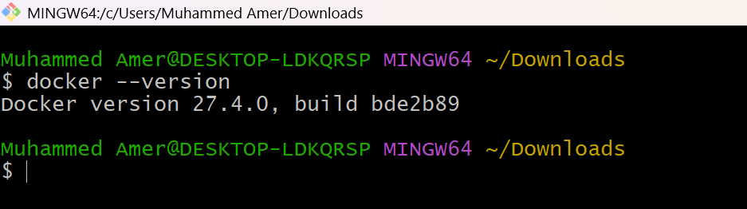  
  
  
  
  
**Step-2**  
  
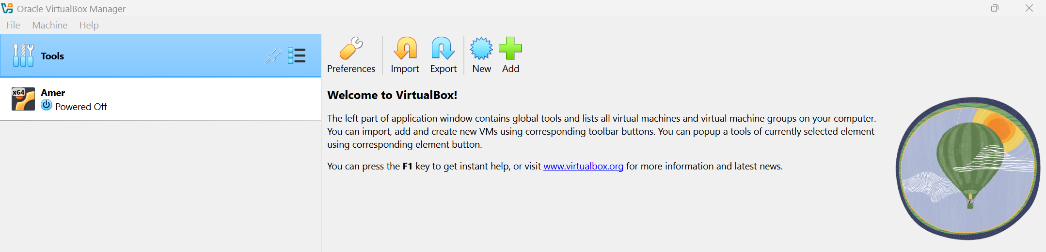  
  
  
  
**Step-3**  
  
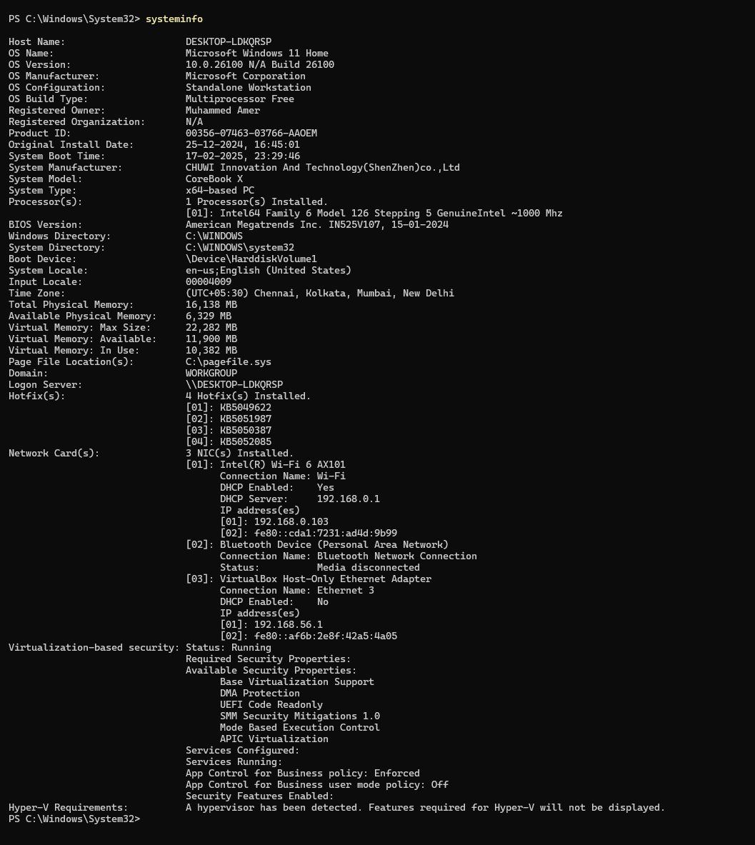  
  
  
**Step-4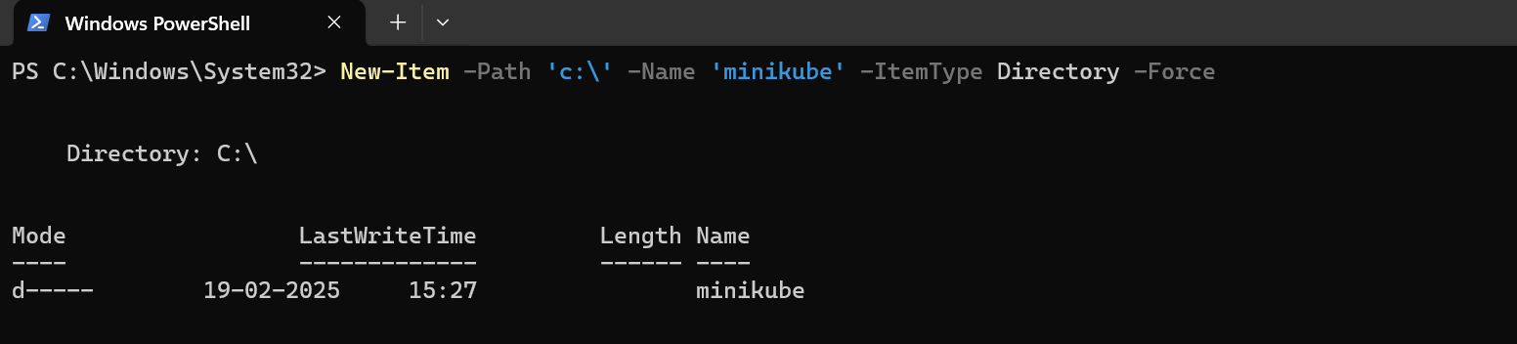 Step-5**  
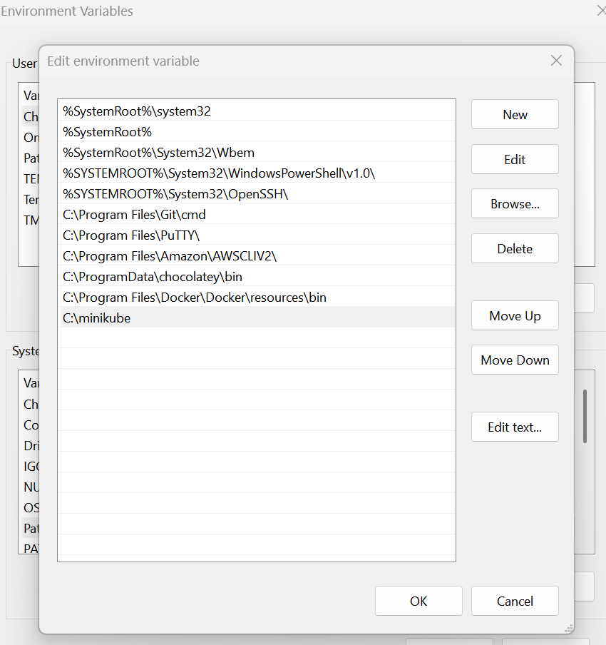  
  
  
  
  
  
  
  
  
  
  
  
  
  
  
  
  
  
  
**Step-6**  
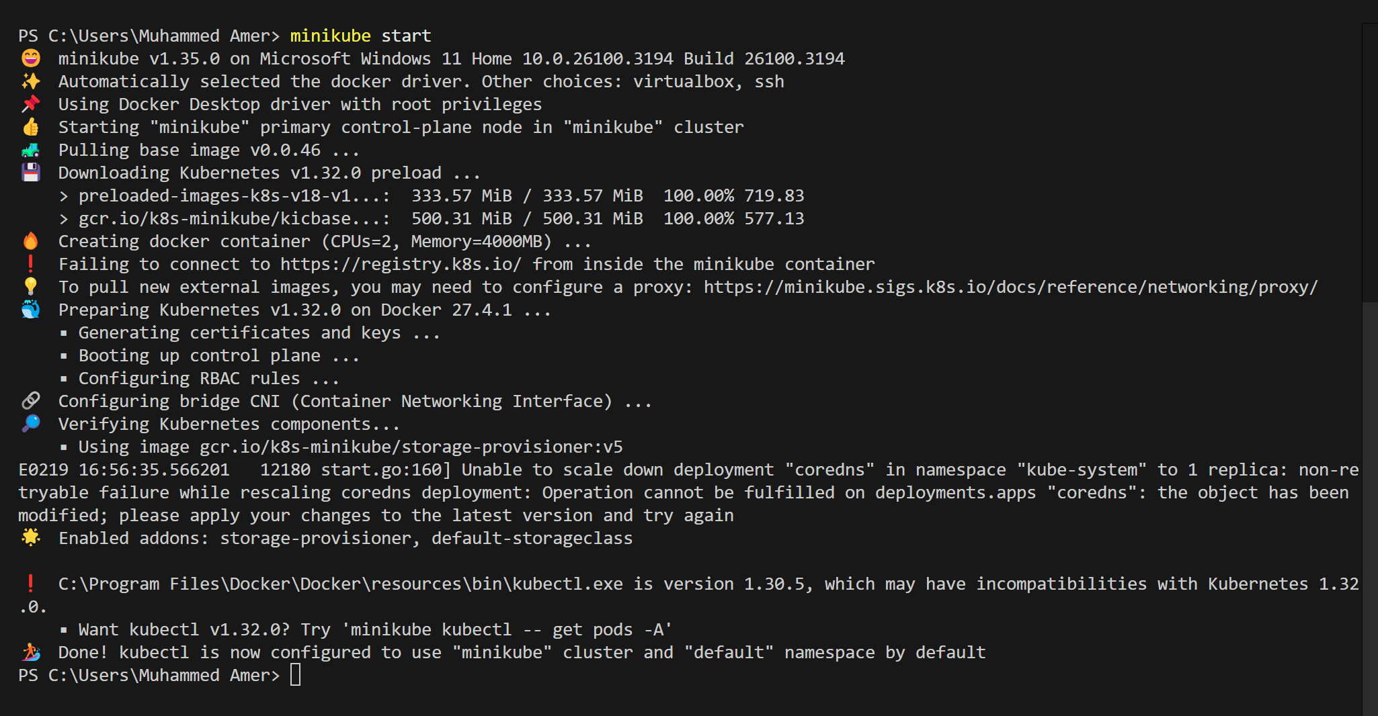  
  
  
  
2) Setup k8s master and two worker nodes on Ubuntu.  
  
--1) launch 3 instances of type t2.medium and linux2 AMI.  
  
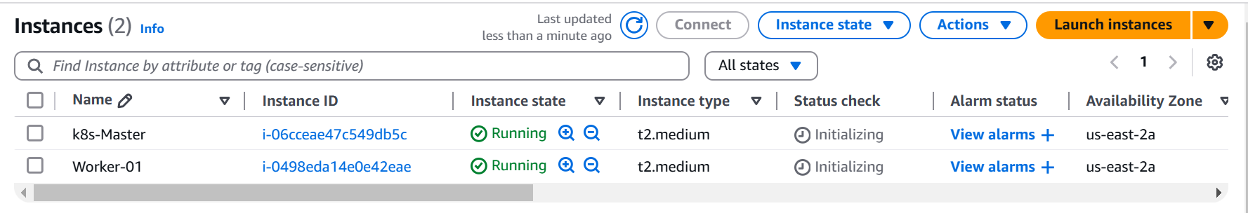

2) Disable swap memory from instances.(Because k8s wants the cpu to utilized 100%)

free - h to check the swap memeory allocated

swapoff -a to off the swap memory

To not enable this after restart then comment this in fstab file.

3) Install docker based on Operating system in 3 instances.

<https://docs.docker.com/engine/install/>  
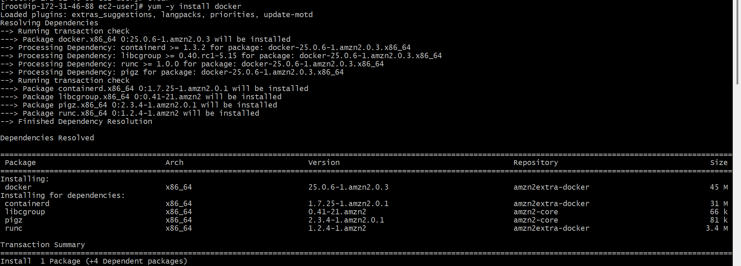

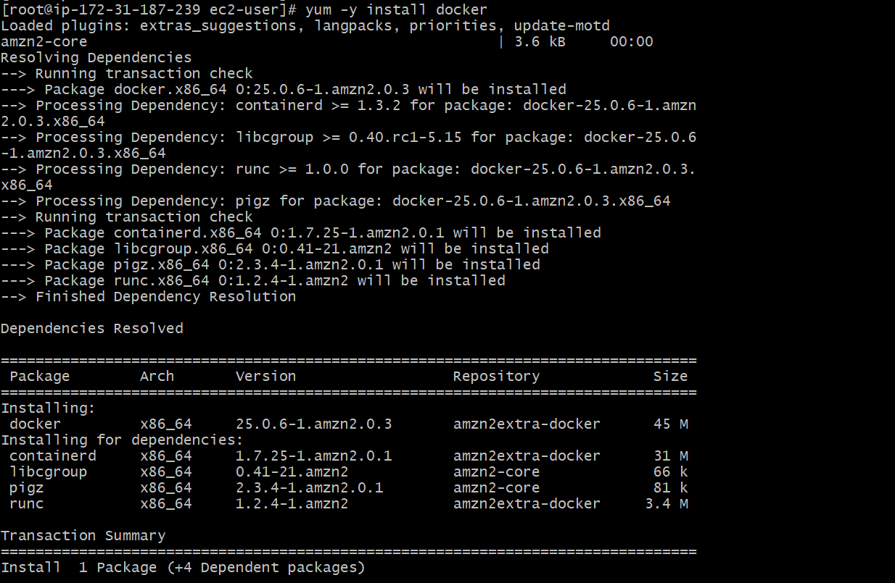  
  
  
  
  
4) To setup k8s cluster we have different tools like kops and kubeadm.

https://kubernetes.io/docs/setup/production-environment/tools/kubeadm/install-kubeadm/

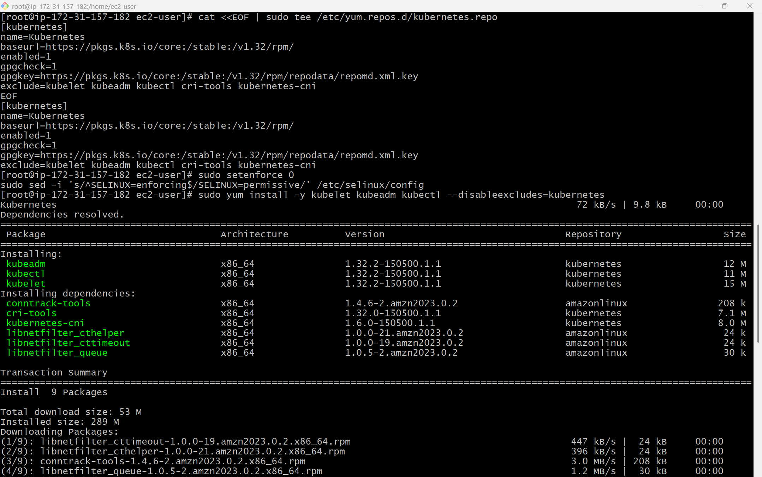  
  
  
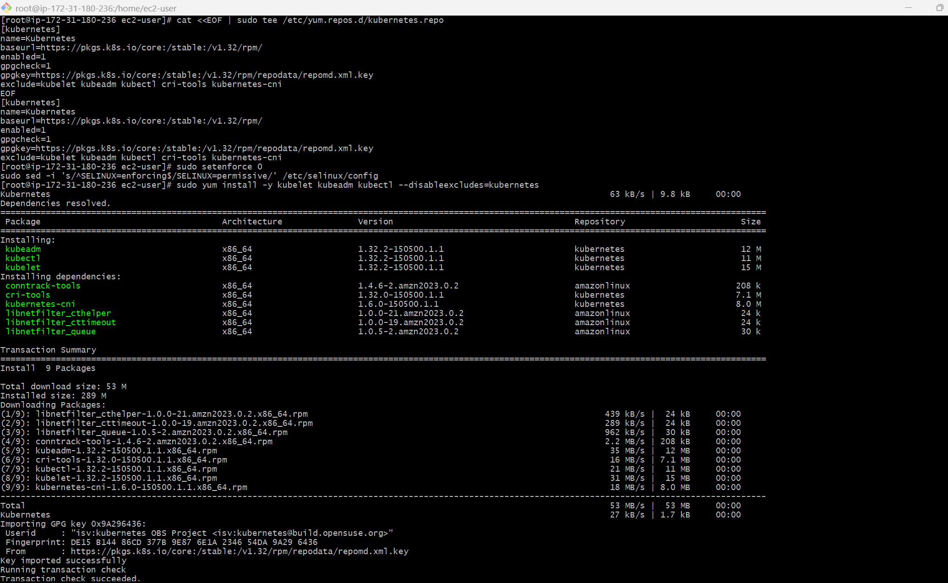  
  
  
  
5) Now we need to setup networking and configure master and worker nodes.

[https://kubernetes.io/docs/setup/production-environment/tools/kubeadm/create-cluster-kubeadm/  
6) TO configure master we need to initialize with CIDR](https://kubernetes.io/docs/setup/production-environment/tools/kubeadm/create-cluster-kubeadm/)

[kubeadm init --pod-network-cidr=10.244.0.0/16](https://kubernetes.io/docs/setup/production-environment/tools/kubeadm/create-cluster-kubeadm/)

[7) To start using your cluster, you need to run the following as a regular user:](https://kubernetes.io/docs/setup/production-environment/tools/kubeadm/create-cluster-kubeadm/)

[mkdir -p $HOME/.kube](https://kubernetes.io/docs/setup/production-environment/tools/kubeadm/create-cluster-kubeadm/)

[sudo cp -i /etc/kubernetes/admin.conf $HOME/.kube/config](https://kubernetes.io/docs/setup/production-environment/tools/kubeadm/create-cluster-kubeadm/)

[sudo chown $(id -u):$(id -g) $HOME/.kube/config](https://kubernetes.io/docs/setup/production-environment/tools/kubeadm/create-cluster-kubeadm/)

[8) If we execute kubectl get nodes we can see the status as notready because we haven't installed flannel](https://kubernetes.io/docs/setup/production-environment/tools/kubeadm/create-cluster-kubeadm/)

[9) Install Flannel and check the status of nodes](https://kubernetes.io/docs/setup/production-environment/tools/kubeadm/create-cluster-kubeadm/)

[kubectl apply -f https://github.com/flannel-io/flannel/releases/latest/download/kube-flannel.yml](https://kubernetes.io/docs/setup/production-environment/tools/kubeadm/create-cluster-kubeadm/)

[10) Now copy the token and execute on worker machines.](https://kubernetes.io/docs/setup/production-environment/tools/kubeadm/create-cluster-kubeadm/)

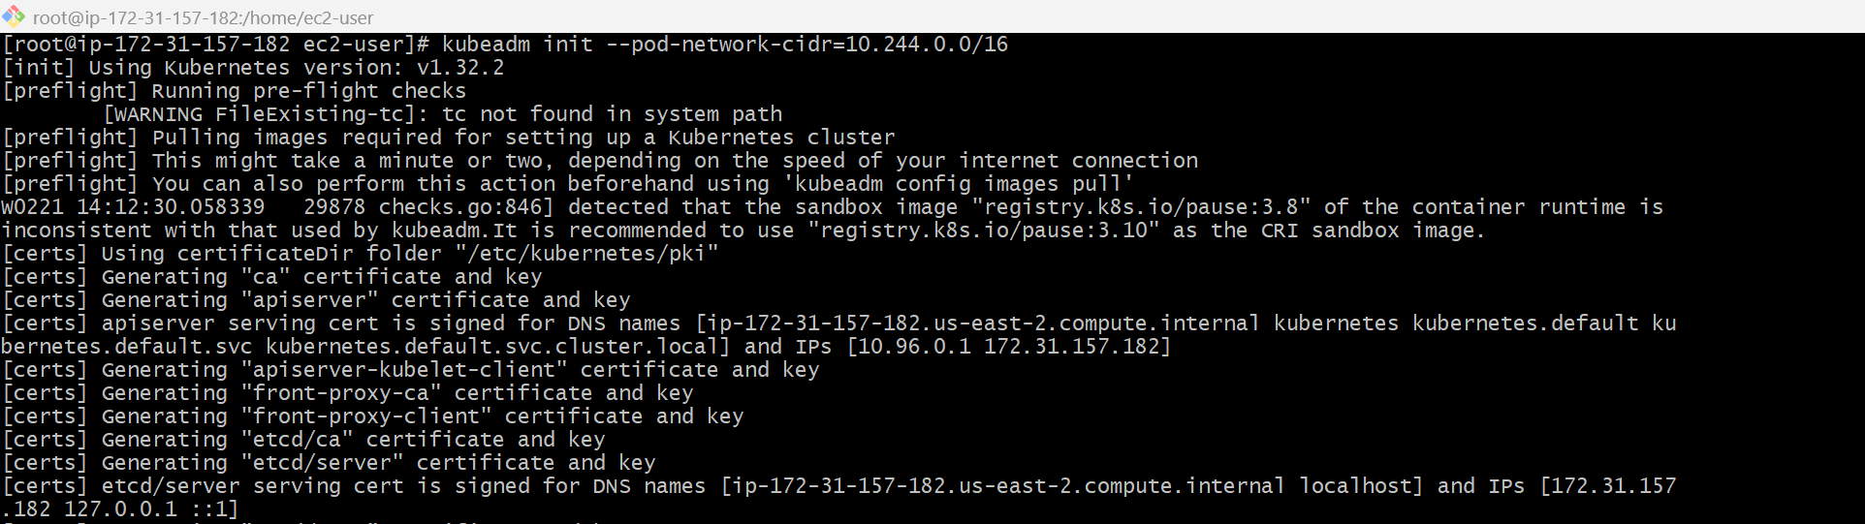  
  
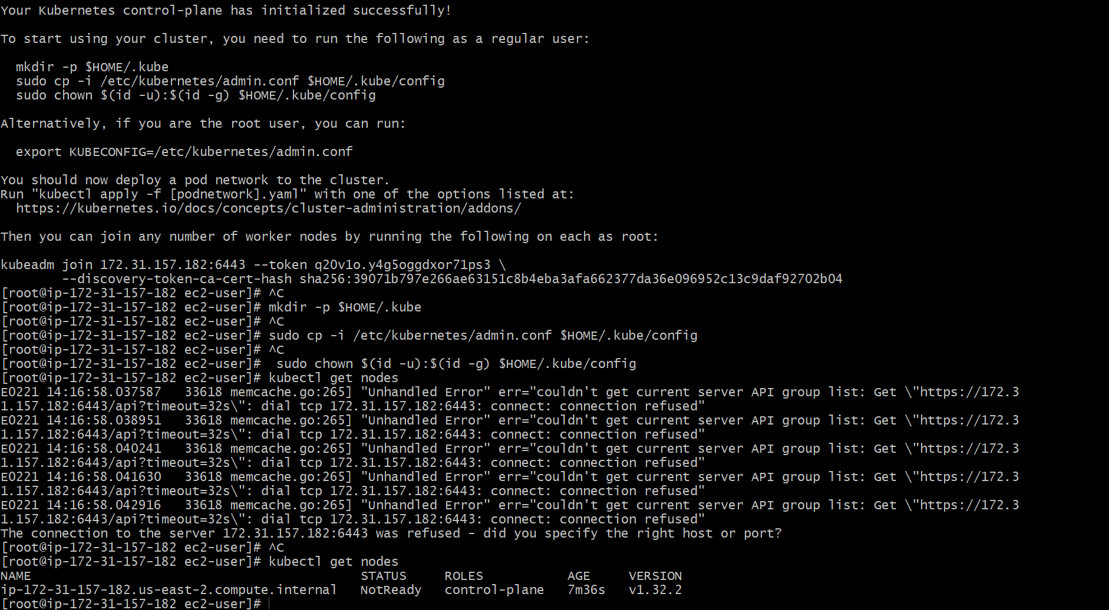

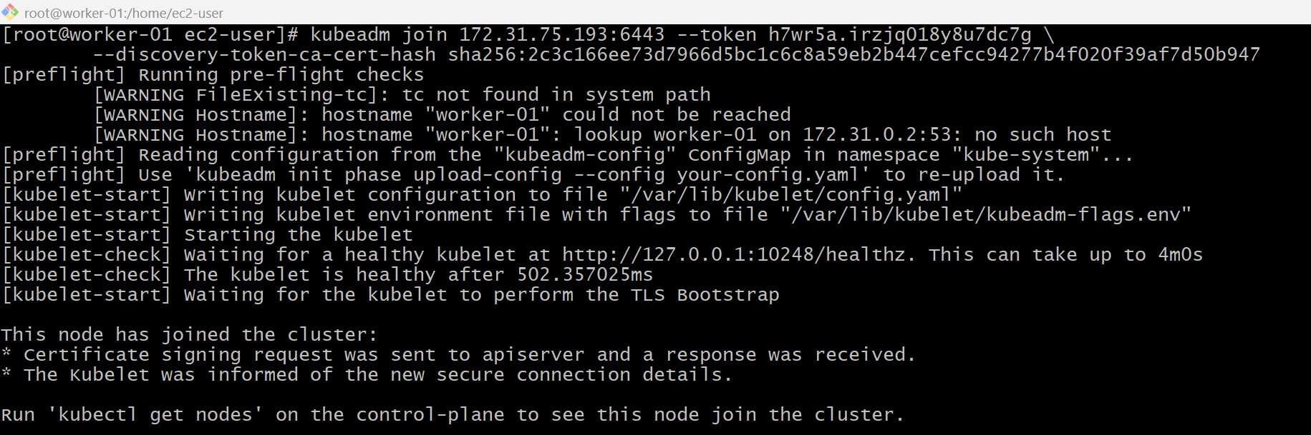  
  
  
  
  
  
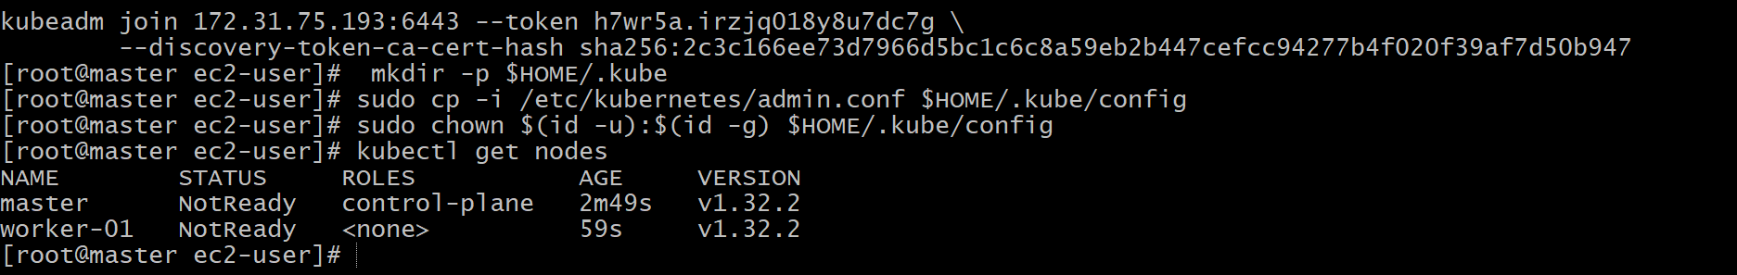  
  
  
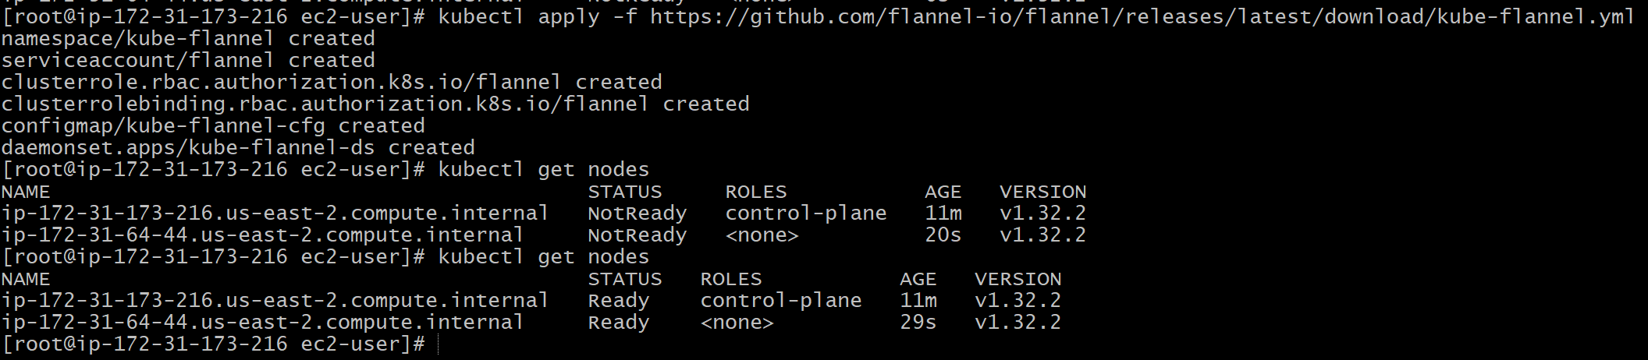

3) Run one nginx pod.

4) Mugup Master and slave components on k8s.